Ex. No 5: Use Autopsy to create a case and import evidence

Date:

Description


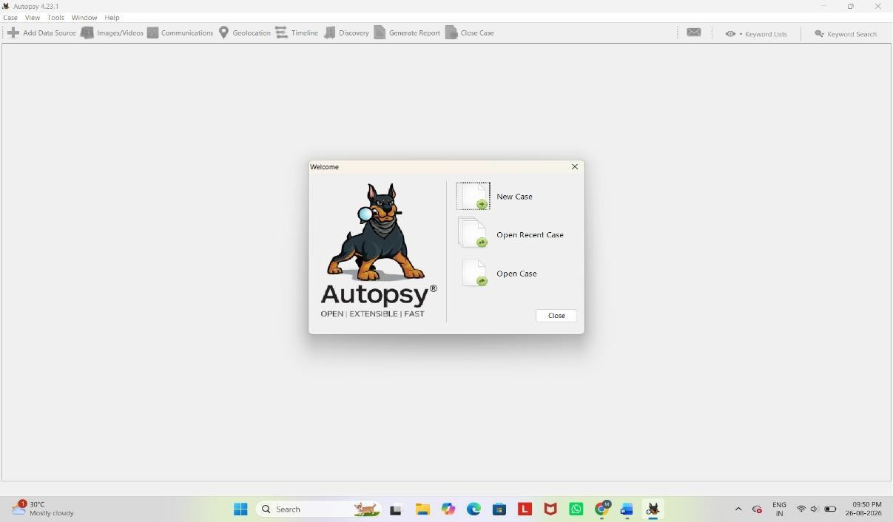
Autopsy is an open-source digital forensics platform used for analyzing and extracting data from digital devices. Here's a step-by-step process on how to use Autopsy for a basic forensic investigation:

Installation
  - Download and Install: Autopsy can be downloaded from the official website. Follow the installation instructions based on your operating system (Windows, Linux, or macOS).

Starting a New Case
  - Open Autopsy: Launch the application after installation.

Create a New Case:
    - Click on New Case.
    - Enter the case name and location where the case data will be stored.
    - Fill in the details like the case number, examiner's name, etc., and click Next.

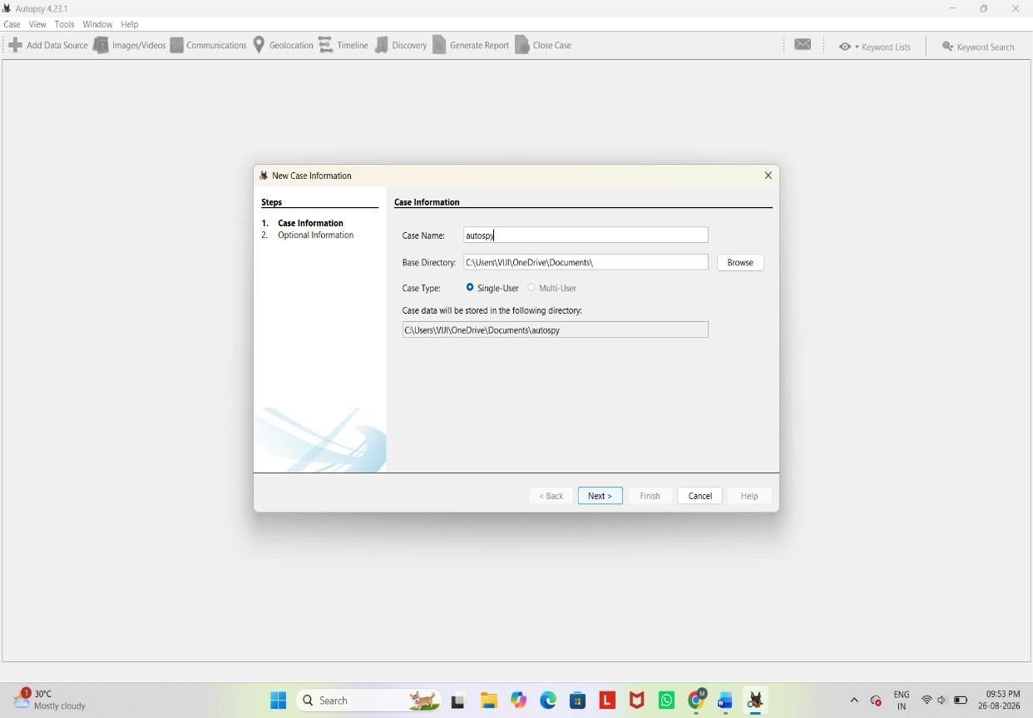

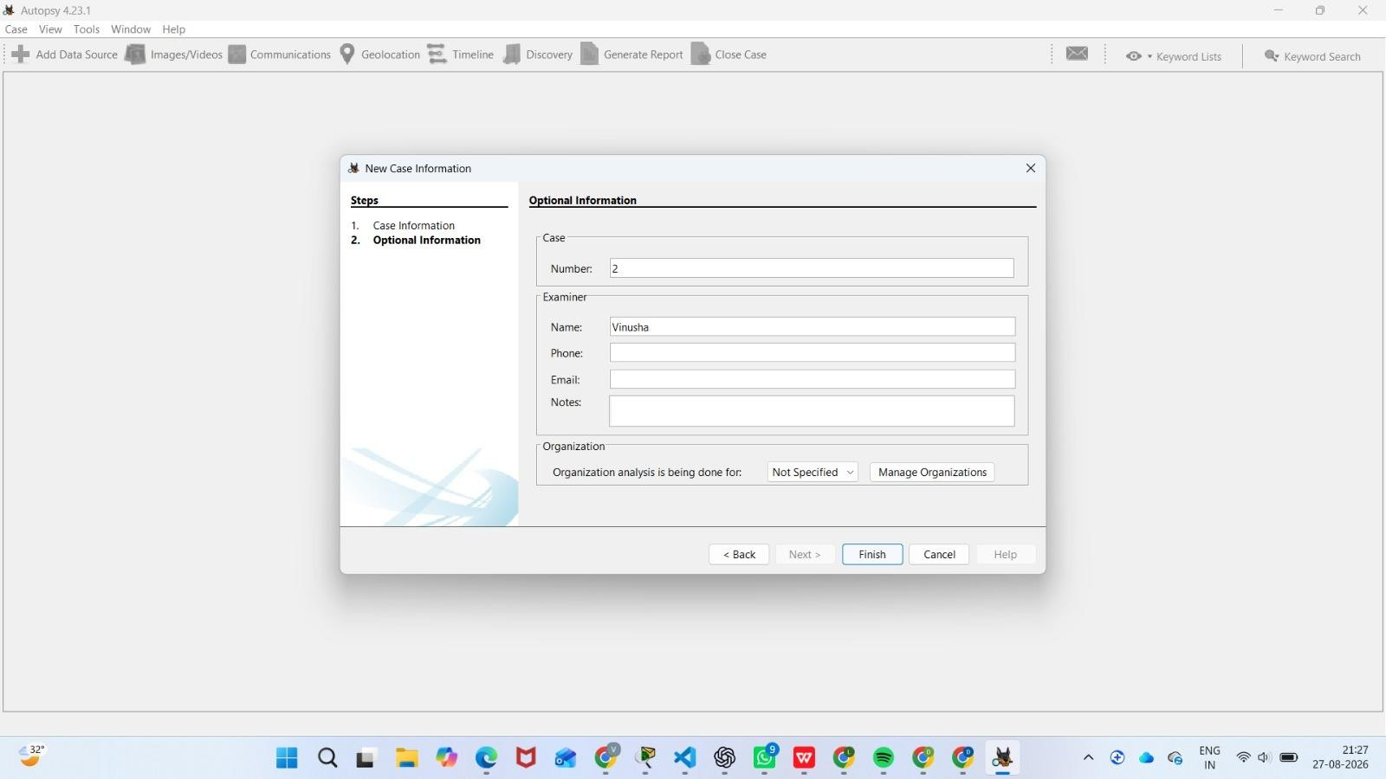

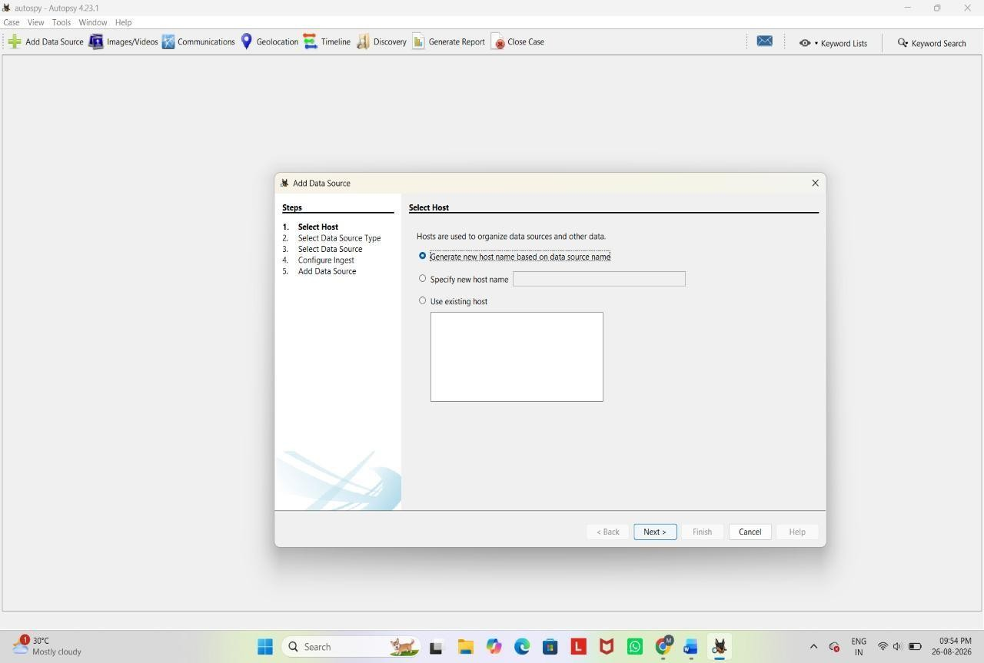
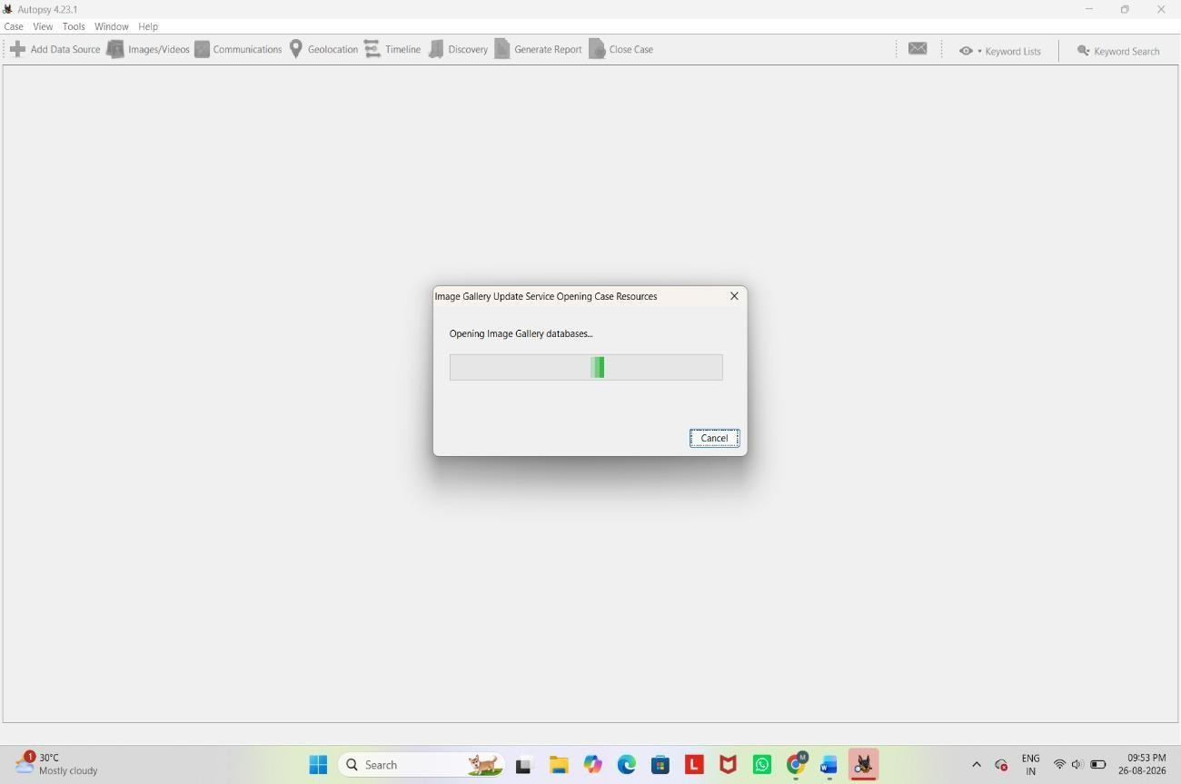

Adding a Data Source
  - Choose the Type of Data Source:
    - After creating a case, you'll be prompted to add a data source.
    - You can add disk images, directories, logical files, or local disks.

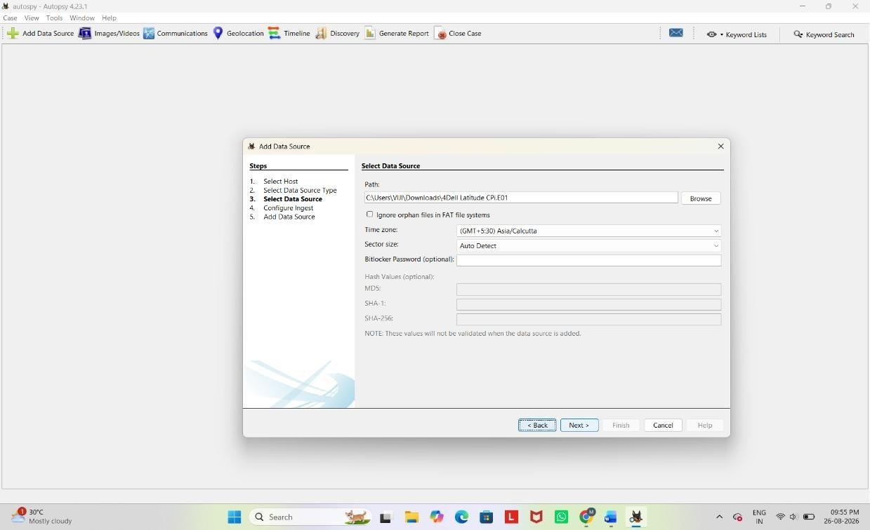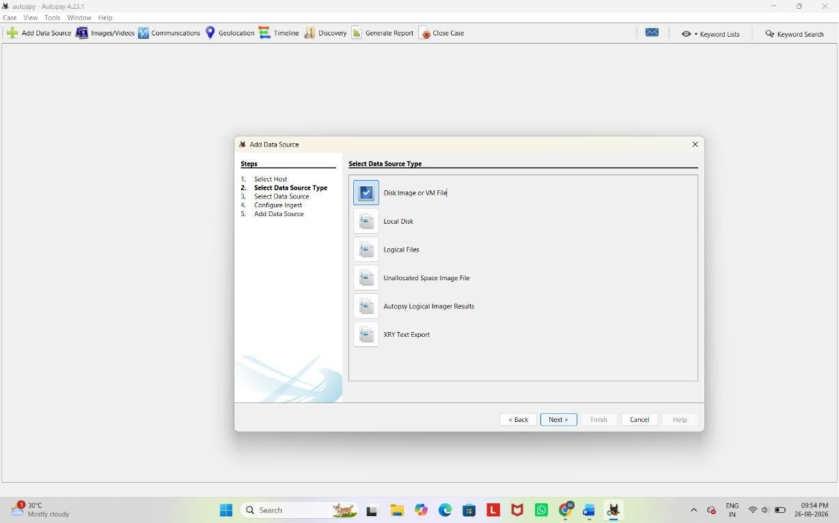

Select the Data Source:
- Browse to the location of the image file (e.g., .E01, .dd, or .raw), physical disk, or directory you want to analyze.

Configure Ingest Modules:
    - Autopsy allows you to select specific analysis modules such as File Type Identification, Keyword Search, Hash Lookup, etc.

    - You can enable or disable these based on your investigation needs.
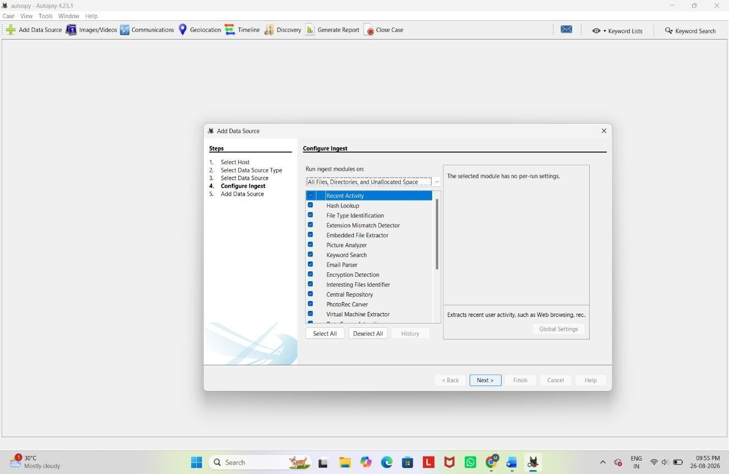

- Start Analysis: Click Next to start the analysis.
4. Initial Analysis and Overview
- Ingest Progress: As Autopsy processes the data source, you'll see the progress in the lower-left corner.
- Explore the Resulting Artifacts:
  - Autopsy automatically categorizes findings such as web artifacts, file system metadata, and communication records.
- Use the Tree Viewer:
  - On the left pane, you’ll see a tree structure where you can explore different aspects like File System, Web History, Email, etc.

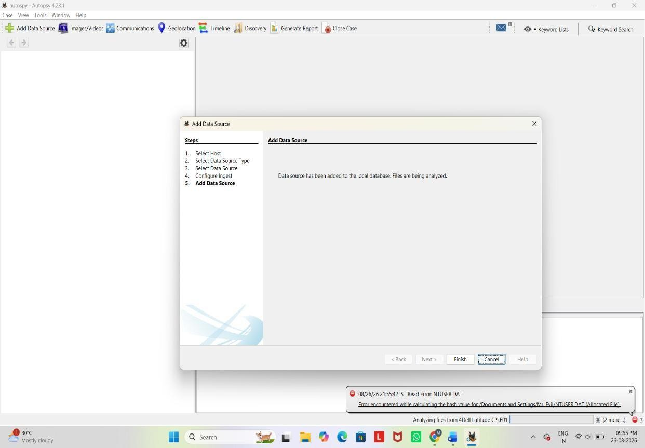

- Detailed Analysis
  - Keyword Search:
    - You can perform specific keyword searches using the Keyword Search module.
    - Use pre-configured lists or enter custom keywords.
  - File Analysis:
    - Navigate through files and folders under the File Types or File System section.
    - Open, view, or export files for further examination.
  - Timeline Analysis:
    - Use the Timeline module to visualize events based on timestamps.
    - This can help track user activity over time.
  - Hash Analysis:
    - Compare file hashes with known databases to identify known good or bad
files.

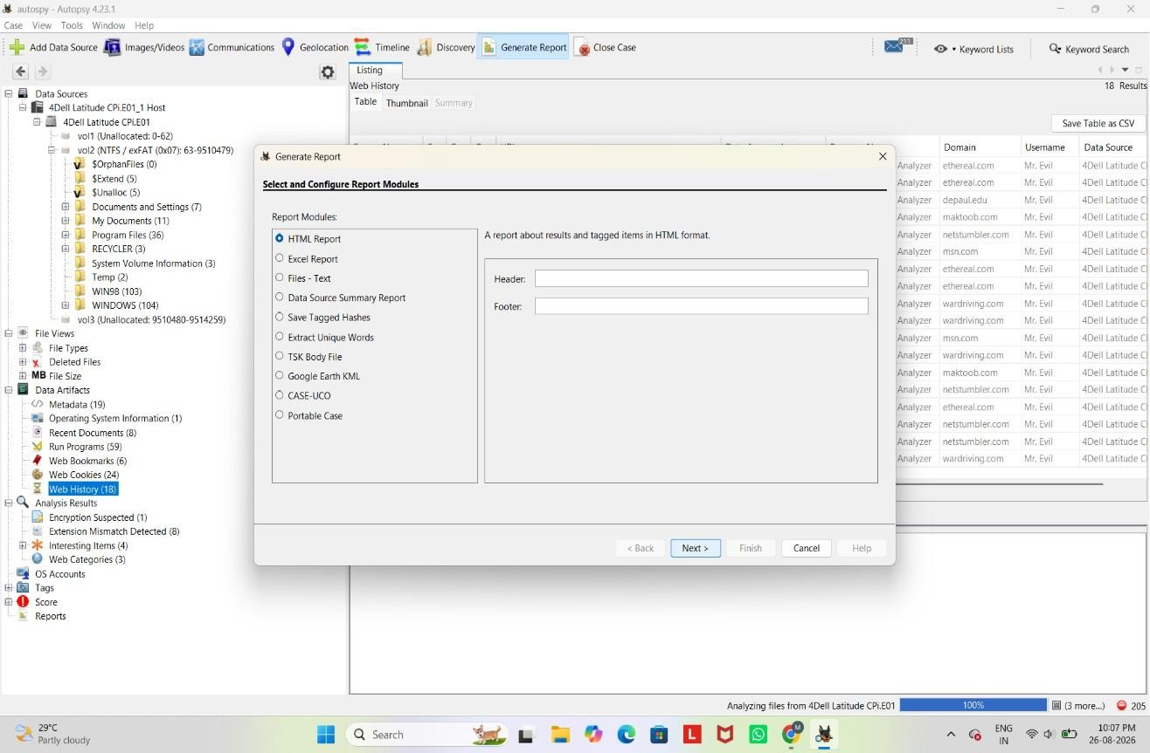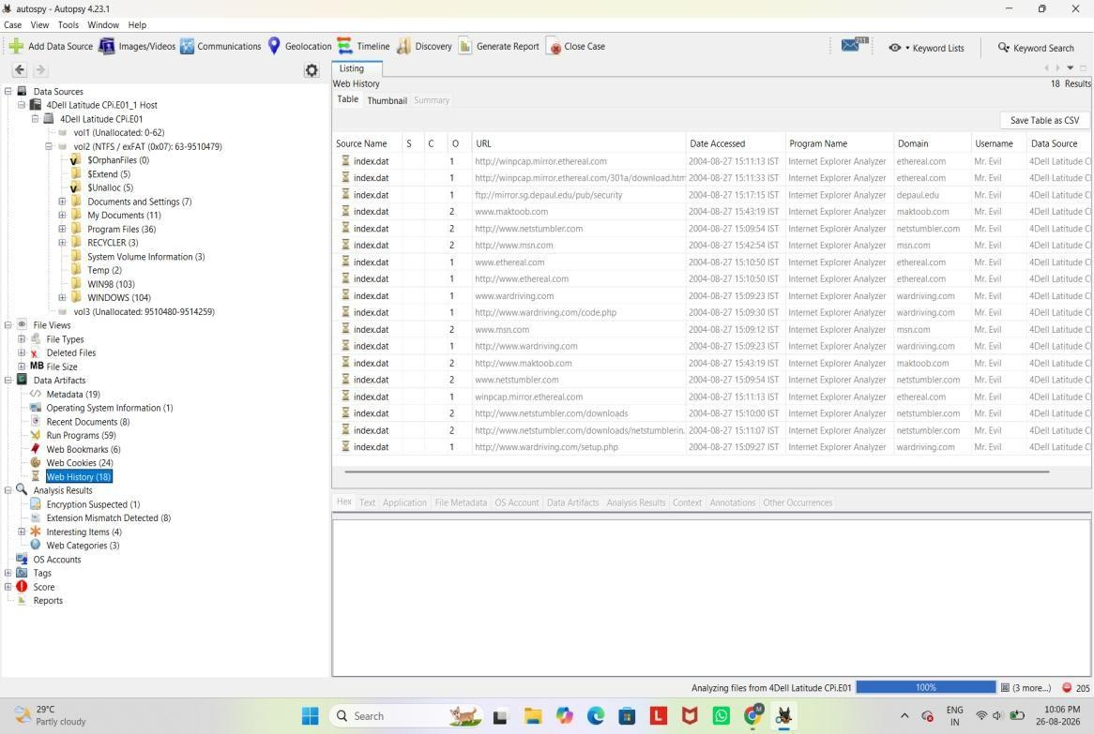

Reporting
  - Generate a Report:
    - After analyzing the data, click on Generate Report from the toolbar.
    - Choose the type of report (HTML, CSV, Excel, etc.).
    - Select which parts of the analysis you want to include in the report.

Export Findings:
    - Export individual files or artifacts that you need for your report or further analysis.

Final Review:
    - Review the report to ensure it includes all relevant information.
    - Save or print the report for use in your case.
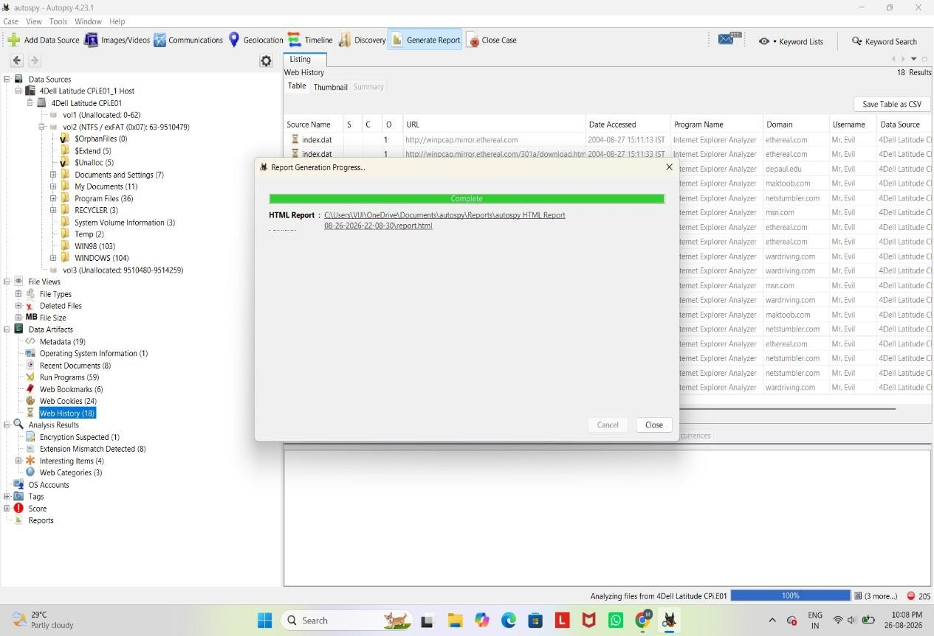
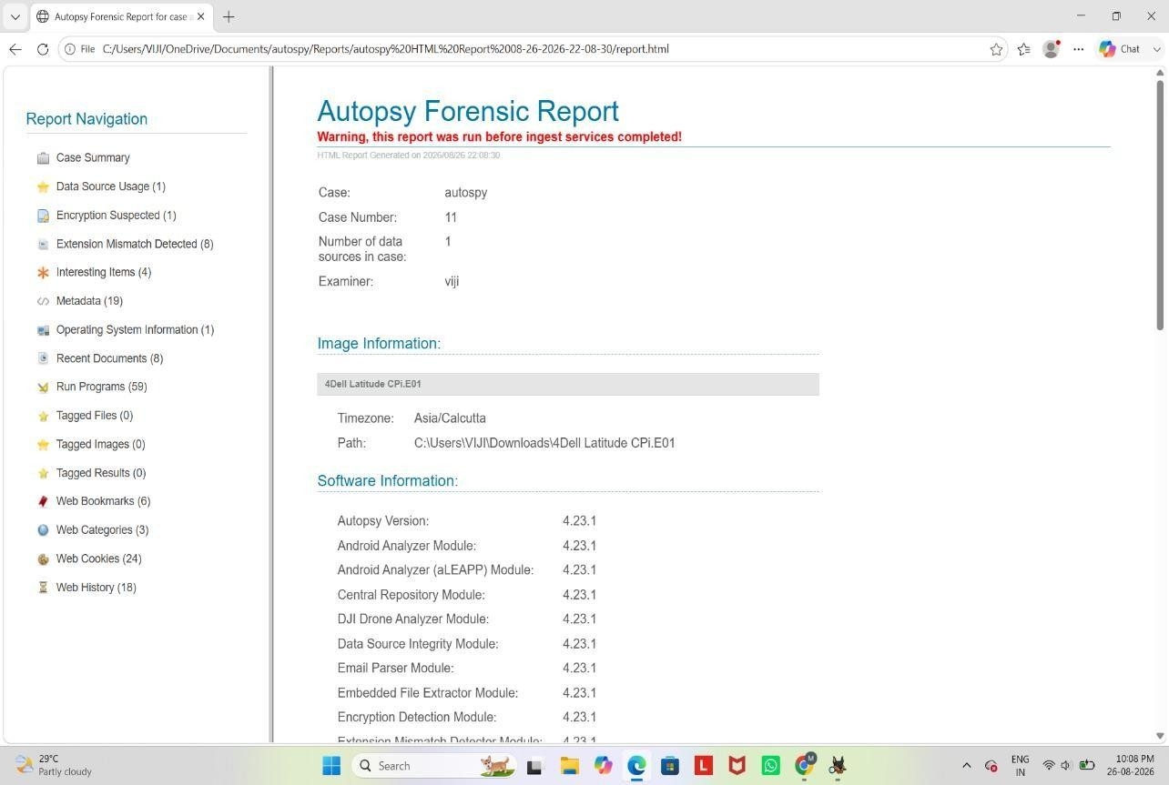

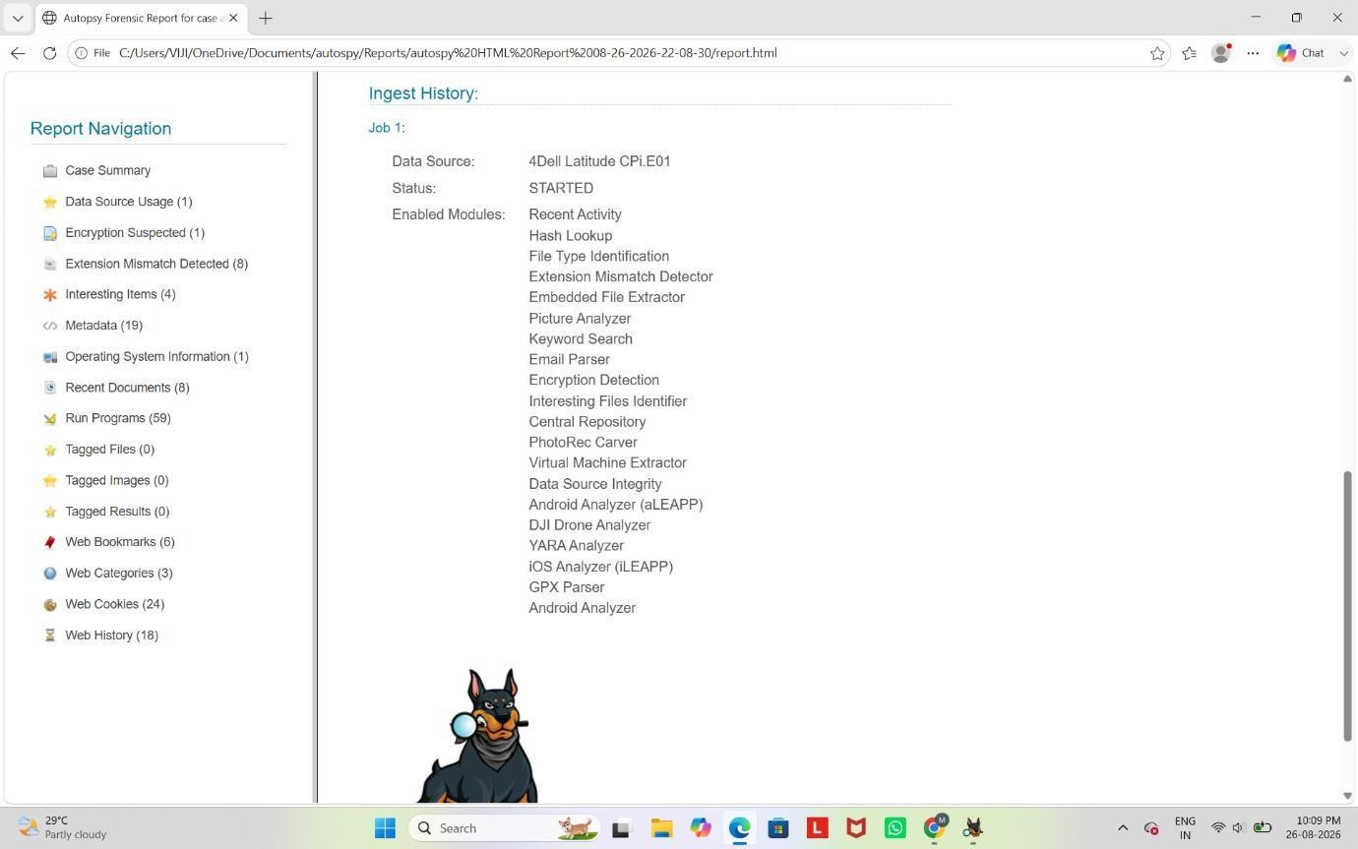

- Case Closure
  - Close the Case:
    - Once you have completed your investigation, close the case within Autopsy.
  - Archiving:
    - Ensure all data and reports are properly archived according to your organization's policies.
- Advanced Features (Optional)
  - Custom Ingest Modules:
    - Autopsy allows for custom modules to be added if you need specific analysis tools not included by default.
  - Collaboration:
    - Autopsy can be configured for multi-user cases if you’re working in a team environment.

